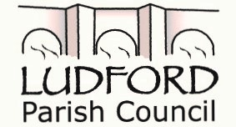

Chair: Clerk:
Imogen Liddle Penny Brasenell
The Larches, Longville
Much Wenlock, TF136EA

To All Ludford Parish Electors
You are invited to attend the Annual Meeting of Ludford Parish on the
21st May 2018
At Ludlow Mascall Centre
At 19.00

A G E N D A

1. Introduction and Welcome from Cllr Imogen Liddle, Chair of Ludford Parish Council
2. Apologies for Absence
3. Reports
a) Ludford Parish Council Chairman’s report for 2017/18 – Cllr Imogen Liddle
b) Communications and Website report – Parish Clerk Penny Brasenell
c) Public Forum – an opportunity to raise issues and concerns or introduce community groups relating to Ludford Parish.
4. Close of Meeting

