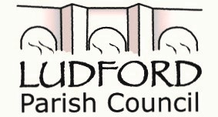
Clerk: Mrs Penny Brasenell, 13 Rorrington, Chirbury SY156BX
Email: clerk@ludfordshropshire.org.uk Phone 03330 062010

To all Members of Ludford Parish Council
You are hereby summoned to attend a Meeting of Ludford Parish Council, to be held on Monday 20th January 2020 commencing at 7pm at The Ludlow Mascall Centre, Lower Galdeford, Ludlow
Yours faithfully
Mrs Penny Brasenell - Parish Clerk
A G E N D A
1. Apologies
2. Declarations of Interest. (a) Personal b) Prejudicial
3. Public Participation: Fifteen minutes maximum is allowed for any questions from the public.
(Councillors should not make immediate decisions on comments and representations made by the public. No discussion shall take place on any question put or comment made. Where practical, the Chair may respond to the question or indicate that a written response will be made and considered at a later meeting, or at the meeting of a particular committee, as the Members may not have all the relevant information to make a valid decision)

4. Report from Shropshire Councillors
5. Minutes: to approve and sign the Minutes of the Parish meeting held on 18th November 2019
6. Matters arising from the minutes.
7. Councillor News
8. Planning matters
9. Correspondence received
10. Finance a) Bank Reconciliation b) Approval of payments made by cheques c) Budget d) Precept 2020
e) Applications for Grants/requests for donations

11. Reports from other organisations
12. Urgent matters not on the Agenda
13. Date of the next meeting 16th March 2020

