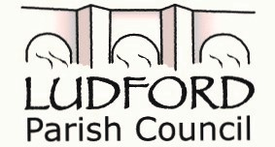

VACANCY FOR A

COUNCILLOR

PUBLIC NOTICE IS HEREBY GIVEN

At the close of nominations on Friday 9th April 2021, Ludford Parish Council still has 3 vacancies.

If you are interested in being a Parish Councillor then please contact the Clerk at the address below

This notice is dated 24th day of May 2021

Clerk to the Council
Mrs Penny Brasenell
13 Rorrington
Chirbury
Montgomery
SY156BX

